1. Procedure to set up ICS for performance in perf environment

- Install ICS on linuxcas1, which is perf box for ICS. (Follow ICS installation script to do this)

- Login to linuscas01 box using User Id and Password as “infrap”

- Execute “startics” from “/sbt/prod/infra/ics/bin” directory.

- Execute “sar –o <<outputFileName.sar>> 1 3600” from /sbt/prod/infra/ics” directory.
where “1” represents frequency in seconds which “sar” should write into <<outputFileName.sar>> for “3600” sec.

- Verify <<outputFileName.sar>> is created under “/sbt/prod/infra/ics” directory.

- Execute “sar –f <<outputFileName.sar>> | more” to view performance data (CPU usage and etc.) written on to <<outputFileName.sar>> file.

- Execute “top” to view latest performance related details as shown below.
100 - CPU Usage = Idle

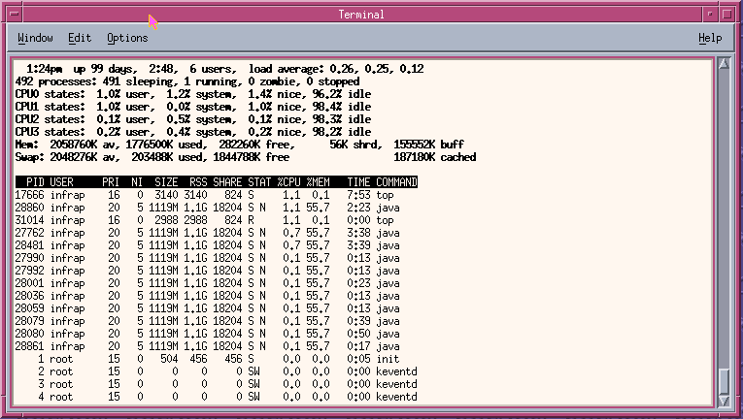
- Execute instrumentation drivers (Refer section 2 and 3 to set up and execute instrumentation drivers) from following machines and observe how is the performance, in a window, which was opened after executing “top” command.

sbtcas12 ( up to 100 drivers)
sbtcas13 ( up to 100 drivers)
sbtcas14 ( up to 100 drivers)
sbtcas15 ( up to 100 drivers)
ics0001 ( up to 200 drivers)

How to run instrumentation drivers i.e. on sbtcas12?
(Refer section 3 to setup and run instrumentation drivers)
(Follow the same procedure for other boxes i.e. sbtcas13, sbtcas14,
sbtcas15 and ics0001)

- Login to sbtcas12 using User Id and Password as “infra”

- Execute following commands: “cd $RUN_DIR/../instGen/run_dir/”
(Verify that current directory changes to “/sbt/test/infra/instGen/run_dir”)
“export INSTGEN_HOME=`pwd`”
“ . setJava.ksh”

- Run “. setTestEnv <<environment>> <<RTServerName>>”
Ex: “. setTestEnv test6 devenv2” OR
“. setTestEnv Prod sbtgc0a”

- Execute “startCASProdLoad.ksh” to run drivers with production load, or “startCASPerfLoad.ksh” to run with performance load, which is almost four times more than the production load.

- Execute “stopInstrumentorGenerators.ksh” to stop all drivers.

How to setup and run instrumentation drivers i.e. on sbtcas12?
(Follow the same procedure for other boxes i.e. sbtcas13, sbtcas14, sbtcas15 and ics0001)

- Login to sbtcas12 using User Id and Password as “infra”

- Go to “/sbt/test/infra” directory.

- Create “instGen” directory under “/sbt/test/infra” directory.
(By executing “mkdir instGen”)

- Create two more directories i.e. “config” and “run_dir” under “/sbt/test/infra/instGen” directories.

- Bring another window and login to your view.
Ex.
  - “telnet ccserv2” (User Id: shanbhag, Pasword:<<****>>)
  - “ct setview shanbhag_shmp3_pw”
  - “cd /vobs/dte/gui/release/clientTest/bin/instrumentation”
  - Run “genInstallArchive.ksh”. This will create “instGen.tar.gz” file
which is compressed file.
  - FTP this file to sbtcas12 i.e. under “sbt/test/infra/instGen/run_dir”.

- On sbtcas12 box, go to “sbt/test/infra/instGen/run_dir”.

- Uncompress this file using “gunzip instGen.tar.gz”. This creates “instGen.tar” file.

- Untar this file using “tar –xf instGen.tar”.

- Go to “sbt/test/infra/instGen/config” directory.

Follow step 10 to step 13 for each of these RTservers : sbtgc0a, sbtgc0b, sbtf0ai, sbtf0bi (all of these for “Prod” environment with User Id: infrap, Password: infrap) and “devenv2” (for test6 environment with UserId: infra, password: infra)

- FTP to RTserver(Ex. sbtgc0a) and provide user id and password as specified above.

- Execute “cd run_dir/properties” and get “cboe.ssconfig.cm” to “sbt/test/infra/instGen/config” of sbtcas12 box.
Make sure “ss.server_names” entry shouldn’t be localhost. If it is “localhost, then update it with primary and secondary RTserver names.
Ex: ss.server_names=sbtgc0a,sbtgc0b when you FTPed to sbtgc0a
ss.server_names=sbtgc0b,sbtgc0a when you FTPed to sbtgc0b
ss.server_names=sbtf0ai,sbtf0bi when you FTPed to sbtf0ai
ss.server_names=sbtf0bi,sbtf0ai when you FTPed to sbtf0bi

Execute “cd ../ior” and get “initrefs.ior” to “sbt/test/infra/instGen/config” of sbtcas12 box.

- Change names of these files as mentioned below:
“mv initrefs.ior initrefs.Prod.<<RTservername>>.ior”
“mv cboe.ssconfig.cm cboe.ssconfig.Prod.<<RTservername>>.cm”

Ex. “mv initrefs.ior initrefs.Prod. sbtgc0a.ior”
“mv cboe.ssconfig.cm cboe.ssconfig.Prod.sbtgc0a.cm”

13) For “test6” environment connect to devenv2, and get “initrefs.ior” and
“cboe.ssconfig.cm” and change names as below:
“mv initrefs.ior initrefs.test6.devenv2.ior”
“mv cboe.ssconfig.cm cboe.ssconfig.test6.devenv2.cm”

14) Copy “env.template.ksh” to Prod and test environment by executing
following commands.
“cp env.template.ksh env.Prod.ksh”
“cp env.template.ksh env.test6.ksh”

15) In sbtcas12, go to “sbt/test/infra/instGen/run_dir” and
run “ln –s ../config/* .”. This will create soft links to all files i.e. “*.ior”
and “*.cm” files in config directory.

Follow step16 to step 19, each time when you start drivers.

16) Run “export INSTGEN_HOME=`pwd`”.

17) Run “. setJava.ksh”.

18) Execute “. setTestEnv <<environment>> <<RTServerName>>”
Ex: “. setTestEnv test6 devenv2” for “test6” environment
“. setTestEnv Prod sbtgc0a” for “Prod” environment.

19) Execute “startCASProdLoad.ksh” to run drivers with production load, or
“startCASPerfLoad.ksh” to run with performance load, which is almost four
times more than the production load.

20) Execute “stopInstrumentorGenerators.ksh” to stop all drivers.

